FULL LIST – COMPLETE ONE OR USE RECIPE CARDS
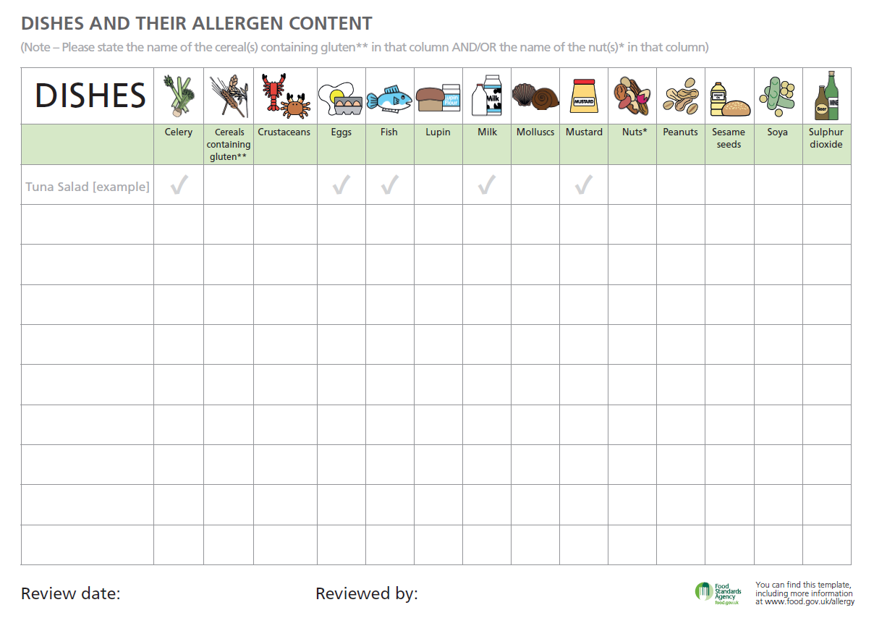
RECIPE CARDS – USE ONE PER ITEM